Project Synopsis

on

**Neural style transfer**

Submitted as a part of course curriculum for

**Bachelor of Technology**

in

**Computer Science**



**Submitted by**

Palak Singh (2000290120103)

Ragini Rani (200290120121)

Kalash Jain (2000290120080)

**Under the Supervision of**

Mr. Akash Goel

(Assistant professor)

**KIET Group of Institutions, Ghaziabad**

**Department of Computer Science**

**Dr. A.P.J. Abdul Kalam Technical University**

**2022-2023**

**TABLE OF CONTENTS**

|  |  |
| --- | --- |
|  | Page No. |
| TITLE PAGE .................................................................................................................... | 1 |
| DECLARATION .............................................................................................................. | 3 |
| CERTIFICATE …........................................................................................................... | 4 |
| ACKNOWLEDGEMENT.................................................................................................. | 5 |
| ABSTRACT...................................................................................................................... | 6 |
| CHAPTER 1 INTRODUCTION |
| 1.1.          Introduction ……………………................................................... | 7 |
| 1.2 Problem Statement .……………………....................................... | 7 |
| 1.2.          Objective………………………………………………………… | 7 |
| 1.3.          Scope…………………………………………………………….. | 8 |
| CHAPTER 2 LITERATURE REVIEW…………………………………………….... | 8-13 |
| CHAPTER 3 PROPOSED METHODOLOGY …………………………………........ | 14-15 |
| 3.1 Flowchart |  |
| 3.2 Algorithm Proposed |  |
| CHAPTER 4 TECHNOLOGY USED ………..………………………..………………. | 15 |
| CHAPTER 5 DIAGRAMS …........................................................................................... | 16-17 |
| CHAPTER 6 CONCLUSION …....................................................................................... | 18 |
| REFERENCES….............................................................................................................. | 19-20 |

**DECLARATION**

We hereby declare that this submission is our work and that, to the best of our by another person nor material which to a substantial extent has been accepted for the award of any other degree or diploma of the university or other institute of higher learning, except where due acknowledgment has been made in the text.

Signature of Students

Name (Roll no): Palak Singh (2000290120103)

Ragini Rani (2000290120121)

Kalash Jain (2000290120080)

Date:

**CERTIFICATE**

This is to certify that Project Report entitled “**Neural Style Transfer**” which is submitted by **Palak Singh, Ragini Rani, Kalash Jain** in partial fulfilment of the requirement for the award of degree B. Tech. in Department of Computer Science of Dr A.P.J. Abdul Kalam Technical University, Lucknow is a record of the candidates own work carried out by them under my supervision. The matter embodied in this report is original and has not been submitted for the award of any other degree.

**Date: Supervisor**

**Signature** Mr. Akash Goel

(Assistant Professor)

**ACKNOWLEDGEMENT**

It gives us a great sense of pleasure to present the synopsis of the B.Tech Mini Project undertaken during B.Tech. Third Year. We owe a special debt of gratitude to Mr. Akash Goel (Assistant Professor), Department of Computer Science, KIET Group of Institutions, Delhi- NCR, Ghaziabad, for his constant support and guidance throughout the course of our work. His sincerity, thoroughness and perseverance have been a constant source of inspiration for us. It is only his/her cognizant efforts that our endeavours have seen the light of the day.

We also take the opportunity to acknowledge the contribution of Dr. Ajay Kumar Shrivastava, Head of the Department of Computer Science, KIET Group of Institutions, Delhi- NCR, Ghaziabad, for his full support and assistance during the development of the project. We also do not like to miss the opportunity to acknowledge the contribution of all the faculty members of the department for their kind assistance and cooperation during the development of our project.

Last but not the least, we acknowledge our friends for their contribution to the completion of the project.

Signature:

Date :

Name (Roll no) : Palak Singh (2000290120103)

Ragini Rani (2000290120121)

Kalash Jain (2000290120080)

**ABSTRACT**

Neural style transfer is a technique that is used to optimize the images which take two input images first one is the content image and the second one is style image, combine these two images and form the output image which looks like a content image but style of the new image is different. In this, we present different estimation techniques and analyze different Neural style transfer (NST) algorithms for loss function that is content loss and style loss. In content loss, it guarantees that the new image does not differ far from the theme of the content image whereas style loss maintains the stylistic difference of the style image. The main objective of NST is to provides a deep learning model that can differentiate the style representation and content image. It is based on Convolutional Neural Networks (CNNs), a deep neural network class which is specifically suitable for image processing. Recent research on neural style transfer has produced some very intriguing findings that have caught the attention of both academics and business. In the NST style, the texture is represented by Gram Matrix Features, which are correlation features derived from the several layers of a pre-trained deep convolutional neural network (often VGG16) trained on the ImageNet dataset to perform object categorization.

**INTRODUCTION**

**1.1-INTODUCTION-**

Neural style transfer aims to enable the Deep Learning model to distinguish between style representations and content images.

NST uses a pre-trained convolutional neural network with additional loss functions to transfer the style from one picture to another and create a new image with the features we wish to add. The process of transferring styles involves activating the neurons in a specific way so that the output image and the content image match particularly well in terms of content, while the style image and the desired output image should match well in terms of texture and capture the same style characteristics in the activation maps.

In a single loss formula, these two goals are merged, and we may choose how much we value both style reconstruction and content reconstruction.

The following data must be provided to the picture style transfer model as inputs:

* A content image is a picture that we wish to add style to.
* A style picture is the look we want the content image to have.
* A produced input picture is the combined result of the content and style images.

**1.2-PROBLEM-STATEMENT-**

One of the most interesting deep learning approaches is neural style transfer (NST). As can be seen below, it merges two images, namely,

* a content image(C) and
* a style image(S),

to create a generated image by combining a content image(C) and a style image(S). The content of the image C and the style of the image S are combined to create the produced image G.

**1.3-OBJECTIVE-**

* To investigate neural style transfer through implementation.
* To transfer style and content from two pictures to and create a new image with the features we want to add.
* To enable the Deep learning model to distinguish between the style representation and content image.

**1.3-SCOPE-**

We can use our project in an app that enables you to add the painting techniques of well-known painters to your own images. The results are rather eye-catching. It is not like Instagram filters, which just alter the image's color space, this alteration affects the entire image. It is far more complex, and the outcomes are even more interesting.

* Gaming
* Commercial Art
* Virtual Reality
* Photo and video editing

**LITERATURE REVIEW**

* The ground breaking work of Gatys et al. showed how Convolutional Neural Networks (CNNs) may be used to separate and then recombine visual content and style to create aesthetic imagery. Neural style transfer is the method used to produce a content image using CNNs in several styles (NST). Since then, NST has gained popularity in both scholarly writing and practical applications. It is drawing more attention, and numerous methods are being put forth to either enhance or expand the original NST algorithm. We hope to give a thorough summary of the development of NST in this work. We first provide a taxonomy of the present NST algorithms. Then, we compare several NST algorithms and give a number of evaluation techniques [1].
* In response to a growing need, this research describes the first effort at stereoscopic neural style transfer for AR/VR or 3D movies. We begin by carefully examining the use of current monocular style transfer techniques views of the stereoscopic pictures individually from the left and right. This shows that the final stylization results cannot adequately retain the original disparity consistency, which leads viewers to get fatigued with 3D. To resolve this problem, add a fresh disparity loss to the commonly used by reinforcing the bidirectional disparity, style loss function restriction in unobstructed areas. We suggest the first feed-forward network by for a workable real-time solution. training a disparity and a stylization sub-network sub-network, then combine them in a medium feature level domain [2].
* We demonstrate interactive painting techniques where a painter collaborates with different neural style transfer algorithms on a physical canvas. Therefore, it is crucial to comprehend the results of these algorithms in order to define the creative. In our interactive experiments, we use agency. We compile a number of coupled painting-picture images and introduce a novel assessment approach based on the neural style transfer algorithms' propensity for predictability. We highlight certain algorithmic flaws and demonstrate how they might be used to increase the variety and aesthetically attractive weirdness of the images produced by the various existing neural style transfer techniques. The computer was shown as a computational catalyst, providing human painters with a variety of pictures that served as a source of inspiration [3].
* Neural style transfer (NST) has evolved significantly in recent research, and several approaches have been improved. However, assessing and enhancing stylization quality continue to be two significant unresolved issues. In this study, we focus on these two characteristics by first breaking down the quality of style transfer into three quantitative components: content fidelity (CF), global effects (GE), and local patterns (LP). Then, two original strategies are offered for utilizing these elements to raise the stylization quality. The first, known as cascade style transfer (CST), makes use of the elements to direct the cascade combination of the current NST techniques in order to make use of their advantages and avoid their own drawbacks. The second method, known as the multi-objective network (MO-Net), directly optimizes these elements in order to balance their performance and provide more aesthetically pleasing outcomes [4].
* The goal of style transfer is to present the information in one picture in the graphical or creative manner of another. The fundamental idea behind Neural Style Transfer (NST) is to view style as a distribution in a Convolutional Neural Network's feature space, making it possible to obtain a desired style by matching its feature distribution. We demonstrate that because most present applications of that idea only partially align the feature distributions, they suffer from significant theoretical and practical restrictions. We provide a unique method that, while still being computationally effective, more closely reproduces the intended style by matching the distributions. To reduce the gap between the goal and actual values, we specifically adopt the dual form of Central Moment Discrepancy (CMD), as recently presented for domain adaptation, to minimize the difference between the target style and the feature distribution of the output image. A obvious extension of current NST techniques that only include the first and second moments is the dual interpretation of this metric, which explicitly matches all higher-order centralised moments. Our research supports the strong theoretical predictions by showing that style transfer and semantic picture content separation are both improved visually [5].
* The quality of stylized photos and procedure speed have been the recent areas of attention in style transfer on photographs. Real-time techniques, however, are incredibly unstable and cause apparent flickering when used with movies. By analyzing the set of solutions to the style transfer aim, we characterize the instability of various strategies in this paper. We demonstrate how the stability of the technique is inversely proportional to the trace of the Gram matrix reflecting style. Then, in order to address the instability of earlier approaches, we develop a recurrent convolutional network for real-time video-style transfer that contains a temporal consistency loss. Our networks create high-quality, temporally consistent styled movies in real-time and may be used at any resolution. They also do not require optical flow during testing [6].
* Drawing beginners to begin learning at a zero skill level has always been difficult; frequently, the procedure itself might deter them from continuing. It would be a time-saving miracle if there were a system that could automatically change line forms into arbitrary styles. In this study, utilizing data extracted from paired pictures for training, we roughly interpret the lines in the image as "words" and the lengthy lines as "sentences" based on the machine translation approach of Sequence-to-Sequence Learning model. Our approach, which can be seen as an imitation of the machine translation process between two languages, extracts line features and then transfers the characteristics to the lines that constituted the input pictures to construct the output images. It has always been challenging to get newcomers to start studying at a zero skill level frequently, the process itself could discourage them from continuing. A device that could transform line forms into other styles automatically would be a time-saving wonder. The lines in the image are approximately interpreted in this study as "words" and the longer lines as "sentences" based on the machine translation strategy of the Sequence-to-Sequence Learning model, which makes use of data retrieved from matched photographs for training. Our method collects line features and then transfers the characteristics to the lines that made up the input photos in order to generate the output images. It may be thought of as an imitation of the machine translation process between two languages [7].
* Fine art collections have been digitally preserved, making images of the works of art kept in museums and galleries publicly accessible to the public. It led to an increase in the need for effective software tools that would enable quick retrieval and semantic categorization of art. This research presents a novel, two-stage picture classification method that aims to increase the style classification precision. The suggested method begins by splitting the input picture into five patches, then using a deep convolutional neural network (CNN) to train and classify each patch separately. When using a shallow neural network trained on the probability vectors provided by the first-stage classifier, the decision-making module at the second stage fuses the results from each of the five distinct patches.  The input picture is divided into categories in the first stage based on individual patches, but the final decision label is inferred in the second stage based on the input image's artistic style. The second stage is trained independently on the first stage utilizing probability vectors instead of pictures, which is the essential reason in increasing the accuracy compared to baseline procedures. This successfully prepares the second step to make up for any potential errors committed during the first stage. The suggested technique was evaluated using a shallow neural network as a second-stage classifier and six different pre-trained CNNs (AlexNet, VGG-16, VGG-19, GoogLeNet, ResNet-50, and Inceptionv3) as the first-stage classifiers. Three common art categorization datasets were used in experiments to show that the suggested technique delivers a significant improvement over the existing baseline techniques [8].
* Despite the vast array of characteristics included in a single style picture, current neural style transfer approaches only frequently yield a single realisation of the style image. Additionally, they do not offer a simple method for controlling the stylization process, which restricts users' creative flexibility. In this study, we introduce Neural Style Palette (NSP), a technique for dynamically producing a range of stylistic pictures using just a single style input. Our method, which was developed in the spirit of hybrid human-artificial intelligence, allows for human input during the stylization process. Similar to a color palette, NSP presents a selection of sub-textures, also known as anchor styles, that serve as a visual cue for the users, enabling a meaningful interaction. Similar to a color palette, NSP presents a selection of sub-textures, also known as anchor styles, that serve as a visual cue for the users, enabling a meaningful interaction. These anchor styles combine several qualities into a single style picture, which users may then creatively combine to get the realizations they want. We confine the anchor styles to be separated from one another while remaining true to the original style picture in order to provide a diverse choice in the NSP. This is made feasible by the two new losses that we suggest: a style separation loss that promotes the sub-textures' individuality and a unification loss that keeps them centred on the primary style while promoting more variation. We conduct various tests to demonstrate the effectiveness of our method and generalize to improve existing methods [9].
* Modern neural style transfer techniques, which train feed-forward convolutional neural networks or employ an iterative optimization process, have produced astounding outcomes. The style representation and content representation of the images employed in these techniques are often based on high-level features taken from pre-trained classification networks. As a result of the classification networks' initial concentration on object recognition, the extracted features frequently overlook minor details in favour of the main object. The style textures thus have a tendency to disperse over the stylistic outputs and interfere with the content structures. We describe a brand-new picture stylization technique that incorporates an extra structural representation in order to overcome this problem. The global structure represented by the depth map and the local structure details provided by the image edges are the two main components of our structure representation represents both the structure of the dominating items as well as the geographical distribution of all the image's constituent parts. The results of the experiments show that our approach is visually successful, which is particularly important when processing photos vulnerable to structure distortion, such as those with several objects that may be at various depths or dominating items with distinct structures [10].
* Fast arbitrary neural style transfer has drawn a lot of interest from the academic, business, and artistic realms because of its adaptability in permitting many applications. Existing approaches either carefully combine deep style and content features without taking feature distributions into account, or they adaptively normalize deep content features in accordance with the style so that their overall statistics are equivalent. They are capable of producing output that is unnatural and has unappealing local distortions, despite being effective at ignoring shallow features and failing to take local feature statistics into account. In order to solve this issue, we provide a brand-new attention and normalization module in this study called Adaptive Attention Normalization (AdaAttN), which performs attentive normalization on a point-by-point basis. Particularly, shallow and deep aspects of content and style images are used to learn the spatial attention score. Then, perpoint-weighted statistics are computed by considering a style feature point to be a distribution of all style feature points' attention-weighted output. In order to present the same local feature statistics as the derived per-point weighted style feature statistics, the content feature is finally normalized. In addition, a unique local feature loss based on AdaAttN is developed to improve local visual quality. We also slightly modify AdaAttN to make it compatible with video style transfer. Our approach achieves state-of-the-art arbitrary image/video style transfer, according to experiments [11].
* In this paper, for the transfer of neural style, we offer a noval approach to produce the given network parameters using a single feed-forward propagation in the meta networks. According to recent style transfer research, image transformation networks must typically be trained for each new style, and the style is then encoded in the network parameters by extensive stochastic gradient descent iterations that lack the ability to generalize to new styles in the inference stage. To solve these problems, we create a meta-network that immediately creates an image transformation network based on the style picture. On a single current GPU card, our meta networks can handle an arbitrary new style in 19 milliseconds as opposed to optimization-based techniques for every style. Our meta-network created a fast image transformation network that is only 449 KB in size and can run in real-time on a mobile device. By using the hidden properties from meta networks, we also look at the variety of style transmission networks. The efficiency of our method has been thoroughly validated through experiments. Release of the code and trained models [12].
* Professional design abilities may be needed for creating logos, fonts, and other embellished shapes. In this study, we use machine learning to stylize common forms in order to create new and distinctive decorative designs. To transfer both local and global characteristics, we specifically merged parametric and non-parametric neural style transfer techniques. To ensure that just the foreground form is painted, we also added distance-based guidance to the neural style transfer process. Finally, qualitative assessment and ablation studies are offered to show the value of the suggested approach [13].

**+-METHODOLOGY**

**2.1-FLOWCHART-**

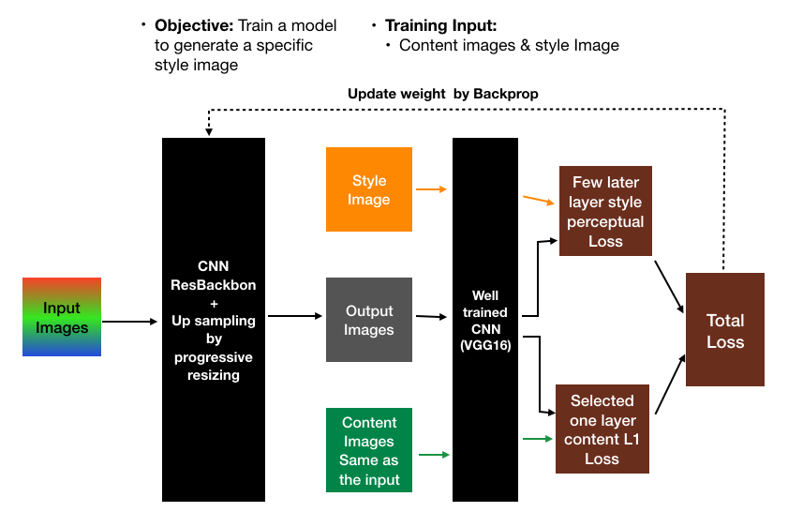

First, the function passes the input image, the transformed images, and the style image to the pre-trained network VGG-16. Multiple features are extracted from these images by this pre-trained network. The spatial properties of the input image and the output image are then used by the algorithm to determine the content loss. The stylistic properties of the output image and the style image are also used to determine the style loss. By combining the content and stylistic losses, it finally determines the overall loss.

**2.2-ALGORITHM USED-**

* **Convolutional Neural Network (ConvNet/CNN)**

A Convolutional Neural Network (ConvNet/CNN) is a Deep Learning method that can take in an input image, give various elements and objects in the image importance (learnable weights and biases), and be able to distinguish between them. Comparatively speaking, a ConvNet requires substantially less pre-processing than other classification techniques. ConvNets have the capacity to learn these filters and properties, whereas in primitive techniques filters are hand-engineered.

A ConvNet's architecture was influenced by how the Visual Cortex is organised and is similar to the connectivity network of neurons in the human brain. Only in a small portion of the visual field known as the Receptive Field do individual neurons react to inputs.

In other words, the network can be trained to understand the sophistication of the image better.

* **VGG16(Visual Geometric Group)**

One of the top computer vision models to date is the CNN (Convolutional Neural Network) variant known as VGG16.

VGG16 is an object identification and classification method that has a 92.7% accuracy rate when classifying 1000 photos into 1000 different categories. It is a well-liked technique for classifying images and is simple to employ with transfer learning.

**TECHNOLOGY USED**

* Tensorflow
* Keras
* Pytorch
* Numpy
* h5py
* Scipy +PIL +Scikit-Image

**DIAGRAMS**

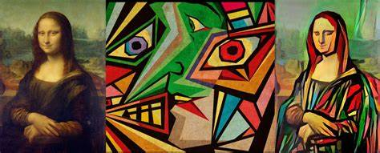

**CONTENT-IMAGE STYLE-IMAGE NEW-IMAGE**

In the above figure, we combine two images, the content image, and the style image, and then generate a new image.

In this figure, we show how content and style are blended to form a new image.

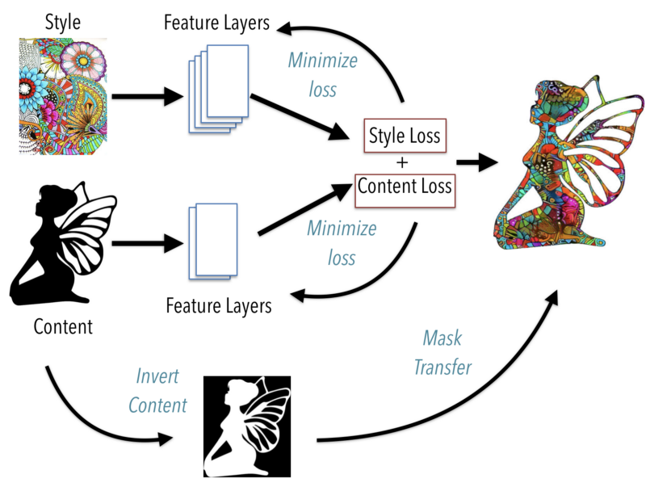

**RESULT**

* The key finding of the Neural style is that the representation of content and style of the Convolutional Neural Network are well separable so that we generate the images which is the mixture of the content and style representation from two different source image.
* It Results on a variety of photographs demonstrate that the suggested method may transfer the style while maintaining the structure and color of the content image, reducing artifacts.

**CONCLUSION**

* This technique helps to recreate the content image in the style of the reference image. It uses Neural Networks to apply the artistic style from one image to another due to which it shows the result of high perceptual quality. Neural style transfer opens up endless possibilities in design, content generation, and the development of creative tools.
* Our study illustrates the advantages of combining international and local losses in the transfer of image style. Fusion architecture refers to designed. A style loss function based on a local method specified in numerous layers is employed on the one hand to maintain the datailed designs.

**REFERENCES**

1. Y. Jing, Z. Feng, J. Ye, and M. Song are with College of Computer Science and v Technology, Zhejiang University, Hangzhou 310027, China - Neural Style Transfer: A Review
2. Dongdong Chen1∗ Lu Yuan2 , Jing Liao2 , Nenghai Yu1 , Gang Hua2 1,University Science and Technology of China 2Microsoft Research - Stereoscopic Neural Style Transfer
3. Thomas Kerdreux∗ Department of Computer Science ENS, PSL University & INRIA Paris, France Louis Thiry∗ Department of Computer Science ENS, CNRS, PSL University Paris, France Erwan Kerdreux Departement of Design ENS Paris-Saclay Palaiseau, France - Interactive Neural Style Transfer with Artists
4. Zhizhong Wang, Lei Zhao∗∗, Haibo Chen, Zhiwen Zuo, Ailin Li, Wei Xing∗∗, Dongming Lu Zhejiang University, Zhejiang, Hangzhou, 310027, People’s Republic of China - Evaluate and Improve the Quality of Neural Style Transfer
5. Nikolai Kalischek Jan D. Wegner Konrad Schindler EcoVision Lab, Photogrammetry and Remote Sensing, ETH Zurich - In the light of feature distributions: moment matching for Neural Style Transfer
6. Agrim Gupta1 Justin Johnson1 Alexandre Alahi1,2 Li Fei-Fei1 Stanford University1 Ecole Polytechnique F ´ ed´ erate de Lausanne ´ 2 - Characterizing and Improving Stability in Neural Style Transfer
7. WEI HE1 AND LIFANG CHEN 1,2, (Member, IEEE) 1School of Digital Media, Jiangnan University,Wuxi 214122,China 2 Jiangsu Key Laboratory of Media Design and Software Technology, Wuxi 214122,China, Received April 21, 2020,accepted June 4, 2020,date of publication June 15, 2020,date of current version June 29, 2020. - A Research of Neural Style Transfer on Line Structure Based on Sequence to Sequence Learning
8. Catherine Sandoval1 , Member, IEEE, Elena Pirogova1 , Margaret Lech1 , Member, IEEE 1 School of Engineering, RMIT University, Melbourne, Victoria, 3000, Australia - Two-stage deep learning approach to the classification of fine-art paintings
9. John Jethro Virtusio, Jose Jaena Marie Ople, Daniel Stanley Tan, M. Tanveer, Neeraj Kumar, and Kai-Lung Hua - Neural Style Palette: a multimodal and interactive style transfer from a single style image
10. Ming-Ming Cheng , Xiao-Chang Liu , Jie Wang, Shao-Ping Lu , Yu-Kun Lai , and Paul L. Rosin, IEEE TRANSACTIONS ON IMAGE PROCESSING, VOL. 29, 2020 - Structure-Preserving Neural Style Transfer
11. Songhua Liu1,2,∗ , Tianwei Lin1,† , Dongliang He1 , Fu Li1 , Meiling Wang1 , Xin Li1 , Zhengxing Sun2,† , Qian Li3 , Errui Ding1 1Department of Computer Vision Technology (VIS), Baidu Inc., 2Nanjing University, 3National University of Defense Technology - AdaAttN: Revisit Attention Mechanism in Arbitrary Neural Style Transfer
12. Falong Shen1∗ Shuicheng Yan2,3 Gang Zeng1 1Peking University 2360 AI Institute 3National University of Singapore - Neural Style Transfer via Meta Networks
13. Atarsaikhan G, Iwana BK, Uchida S (2020) Guided neural style transfer for shape stylization. PLoS ONE 15(6): e0233489. https://doi. org/10.1371/journal.pone.0233489 - Guided neural style transfer for shape stylization